Unit exam with answers

Unit 2 Linear motion and waves

Time permitted: 70 minutes

|  |  |  |  |
| --- | --- | --- | --- |
|  | Section | Number of questions | Marks available |
| A | Multiple choice | 30 | 30 |
| B | Short answer | 8 | 40 |
|  | Total |  | 70 |

Scale:

|  |  |  |  |  |  |  |  |  |  |  |  |  |  |
| --- | --- | --- | --- | --- | --- | --- | --- | --- | --- | --- | --- | --- | --- |
| A+ | 66–70 | A | 60–65 | B | 50–59 | C | 40–49 | D | 35–39 | E | 21–34 | UG | 0–20 |

Section A Multiple choice (30 marks)

Section A consists of 30 questions, each worth one mark. Each question has only one correct answer. Circle the correct answer. Attempt all questions. Marks will not be deducted for incorrect answers. You are advised to spend no more than 30 minutes on this section.

For all questions, the acceleration due to gravity at the Earth’s surface g = 9.8 m–2 and the speed of light in a vacuum is 3.00 × 108.

1 Which of the following is a vector quantity?

A Distance

B Displacement

C Speed

D Kinetic energy

2 A snail is placed 10 cm from the top of a vertically sided bottle. It slips down another 5 cm before someone pushes it up to the top. Find its displacement and the distance it has travelled, counting upwards as positive.

A Displacement 0 cm, distance travelled 20 cm

B Displacement 15 cm, distance travelled 10 cm

C Displacement 10 cm, distance travelled 20 cm

D Displacement 10 cm, distance travelled 15 cm

3 What is the average acceleration if a skateboarder increases her speed from 2.0 m s–1 to 3.5 m s–1 in 0.5 s?

A 0.75 m s–2

B 1.5 m s–2

C 2.0 m s–2

D 3.0 m s–2

4 How would you find the velocity of an object from its displacement–time graph?

A Find the area under the graph.

B Find the height of the graph at that point.

C Find the difference between heights at the start and end of the graph.

D Find the gradient of the graph at that point.

5 What distance has the particle in the graph below travelled?

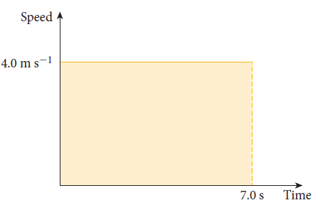

A 0 m

B 4.0 m

C 14 m

D 28 m

6 Which of the following would be most realistic for a driver having to stop suddenly?

A Braking distance = reaction distance + stopping distance

B Reaction distance = braking distance + stopping distance

C Stopping distance = reaction distance + braking distance

D Stopping distance = speed × (reaction time + stopping time)

7 Which of the following is a non-contact force?

A A horse pulling a cart

B Magnetic technology lifting a train

C The force of the floor on a table

D The force of the anchor chain on a ship

8 Which of Newton’s laws applies when you pull on a spring to extend it and at the same time feel it pulling on your hand?

A Newton’s first law

B Newton’s second law

C Newton’s third law

D Newton’s law of gravitation

9 Which of Newton’s laws applies to explain that the Voyager probe is still travelling in a straight line at a constant velocity?

A Newton’s first law

B Newton’s second law

C Newton’s third law

D Newton’s law of gravitation

10 A force acts on a 100 kg mass, as shown in the diagram below. What is the vertical component of the force?

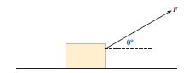

A *F* sin θ

B F cos θ

C F tan θ

D 9.8F

11 A 60 kg man is parachuting vertically down from an aeroplane. What is his acceleration when the upwards air resistance is 288 N? Use g = 9.8 m s–2.

A 4.9 m s–2

B 5.0 m s–2

C 7.5 m s–2

D 9.8 m s–2

12 A satellite orbits Earth at a constant speed. Which statement is true?

A There is no force on the satellite.

B The gravitational force on the satellite is balanced by the centrifugal force.

C The net force on the satellite is zero.

D The velocity is changing in direction due to the external force of gravity.

13 A force of 20 N accelerates a 15 kg mass over 8 m. What is its increase in energy?

A 120 J

B 160 J

C 300 J

D 480 J

14 What is the kinetic energy of a 10 kg mass travelling at 8 m s–1?

A 40 J

B 80 J

C 320 J

D 640 J

15 What is the momentum of a 10 kg mass travelling at 8 m s–1?

A 40 J

B 80 J

C 320 J

D 640 J

16 What is the gain in potential energy if a 10 kg mass is raised 4 m?

A 40 J

B 80 J

C 98 J

D 392 J

17 Why do brakes get hot when they are used to stop a car?

A The work done by the brakes produces heat energy.

B Kinetic energy is converted to heat energy.

C Potential energy is converted to heat energy.

D The momentum of the car is transferred to the particles in the brakes.

18 What is the power involved if a 200 N force acts on a body moving at 8 m s–1 in the direction of motion?

A 800 W

B 1200 W

C 1600 W

D 3200 W

19 What is the impulse involved if a 50 N force acts for 6 s on a 12 kg body in the direction of motion?

A 36 N m

B 72 N m

C 300 N m

D 600 N m

20 What is the change in velocity if a 50 N force acts for 6 s on a 12 kg body in the direction of motion?

A 25 m s–1

B 30 m s–1

C 72 m s–1

D 300 m s–1

21 Which one of the following is true of mechanical waves?

A Matter is being transmitted in the direction of the wave.

B Energy is being transmitted in the direction of the wave.

C Waves can be represented by a ray drawn parallel to the wave fronts.

D Mechanical waves are the only form of energy that can travel through space.

22 What is the period of a wave?

A The distance between two crests of the wave

B The time between two crests passing

C The largest distance of a particle from its mean position

D The number of crests that pass in a fixed time

23 Which of the following is not true of longitudinal waves?

A The particles move back and forth in the direction of energy transfer.

B Sound waves are an example of longitudinal waves.

C Longitudinal waves have areas of compression and rarefaction.

D The particles move perpendicularly to the direction the wave is travelling.

24 If a car sounded its horn when stationary, and again when moving rapidly toward you, what would be the difference in sound?

A When the car is moving toward you the sound is higher pitched.

B When the car is moving toward you the sound is lower pitched.

C When the car is moving toward you the sound is louder.

D There would be no difference between the two sounds.

25 What is diffraction of waves?

A Waves spread into a space beyond a gap or an obstacle.

B Waves bend (change direction) when entering a different medium.

C Waves can be reflected.

D The speed of waves changes when entering a different medium.

26 Which of the following is true about light?

A Light is a longitudinal wave.

B Light is a transverse wave.

C Light is a stream of infinitesimal particles called photons.

D Light sometimes behaves like a wave and sometimes like particles.

27 Which of the following types of electromagnetic radiation has the lowest frequency?

A visible light

B radio waves

C γ rays

D infra-red light

28 Which of the following is the angle of incidence?

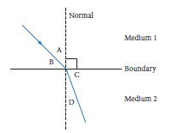

A Angle A

B Angle B

C Angle C

D Angle D

29 What is Snell’s law, if i = angle of incidence and r = angle of refraction?

A i = r

B  is constant.

C  is constant.

D  is constant.

30 The refractive index of water is 1.33 and the refractive index of flint glass is 1.65. What is the refractive index of flint glass relative to water?

A 0.32

B 0.81

C 1.24

D 1.46

Section B Short answer (40 marks)

Section B consists of 8 questions. Write your answers in the spaces provided. You are advised to spend 40 minutes on this section.

1 A small rocket of mass 1.5 kg is powered by a force of 21 N which acts for 10 s.

a What impulse is provided by the net force on the rocket?

Answer: Gravitational force = mg

= 1.5 kg × 9.8 N kg–1

= 14.7 N (1 mark)

Net force = 21 N – 14.7 N = 6.3 N upwards (1 mark)

Impulse = 6.3 × 10 = 63 N s (1 mark)

b Find the rocket’s momentum the instant the force is no longer acting on the rocket.

Answer: Δp = I= 63 kg m s–1

p = 63 kg m s–1 since initial momentum is zero. (1 mark)

c Find the rocket’s velocity and kinetic energy at this point.

Answer: Δp = I = mv – mu

1.5 kg × v = 63 kg m s–1

v = 42 m s–1 (1 mark)

Kinetic energy = 0.5 × 1.5 kg × 42 m s–1 = 1323 J (1 mark)

d How much higher will the rocket rise?

Answer: u = 42 m s–1, v = 0 m s–1, a = –9.8 m s–2

v2 = u2 + 2as

0 = 42 m s–1 + 2 × (–9.8 m s–2) × s

s = 90 m higher (1 mark)

e How much work has been done by the net force on the rocket?

Answer: Work = ΔE = 1323 N m – 0 = 1323 N m (1 mark)

f Use the result in part **e** to find the total height the rocket will reach.

Answer:

Work = Fs = 1323 J 6.3 N × s = 1323 J s = 210 m

Total height = 210 m + 90 m = 300 m (1 mark)

g Show that the total energy at the point in part **c** (potential and kinetic) is equal to the potential energy at its highest point.

Answer: In part c the rocket is 210 m high.

Potential energy = mgh = 1.5 kg × 9.8 m s–2 × 210 mm = 3087 J

Total energy = 3087 J + 1323 J = 4410 J (using the result from part c)

At maximum height, potential energy = mgh = 1.5 kg × 9.8 m s–2 × 300 m= 4410 J (1 mark)

(10 marks)

2 A small rocket of mass 1.5 kg is at rest in space and contains 300 g of propellant. The explosive propellant is forced away from the rocket, at an average velocity of 60 m s–1.

a Find the final velocity of the rocket.

Answer: Initial momentum is zero and equals final momentum.

Final momentum = 1.5 kg × v + 0.3 kg × (–60 m s–1) = 0 (1 mark)

1.5 kg × v – 18 kg m s–1 = 0 v = 12 m s–1 (1 mark)

b Explain how Newton’s third law applies to this situation.

Answer: There is a force by the rocket on the propellant, forcing it away from the rocket. This results in an equal and opposite force on the rocket by the propellant, forcing the rocket forward. (A similar explanation would suffice.) (1 mark)

(3 marks)

3 A person is pulling on a 75 kg crate on a rough surface with a rope, as shown in the diagram.

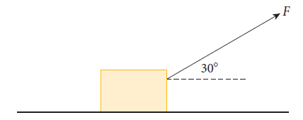

a Show all forces acting on the crate.

Answer:

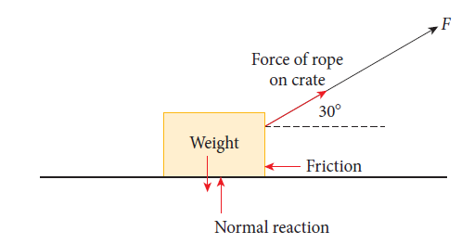 (½ mark per force = 2 marks)

Note: The normal reaction is the force of the ground on the weight.

b Find the value of each of these forces if the crate is moving at constant velocity and the person is pulling with a force of 500 N.

Answer: Force of rope on crate = 500 N

Weight = mg = 75 kg × 9.8 N kg–1 = 735 N (1 mark)

Upwards component of rope force = 500 sin 30° N = 250 N

Net force on crate = 0 N as its velocity is constant.

Horizontal components: normal – 250 N = 0

Normal reaction = 250 N (1 mark)

500 cos 30° – friction = 0

Friction ≈ 433 N (1 mark)

(5 marks)

4 A barge is being dragged along by two people as shown. One is pulling with a force of 200 N at N65°E and the other is pulling with a force of 250 N at S60°E. Find the magnitude and direction of the resultant force.

Answer: Draw a diagram.

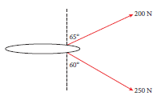

(1 mark)



Add the vectors.



Horizontally: 200 sin 65° N + 250 sin 60° N = 397.7679… N (1 mark)

Vertically: 250 cos 60° N – 200 cos 65° N = 40.4763… N (1 mark)

Magnitude: N ≈ 400 N (1 mark)

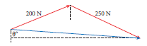

Direction: tan θ =  = 9.827… θ ≈ 84°

The resultant is 400 N at S84°E. (1 mark)

(5 marks)

5 Artificial waves are being made in a swimming pool. The distance from top (crest) to bottom (trough) is 1.6 m and the five waves are being produced every 4 s. The waves take 20 s to travel the 50 m length of the pool. Find:

a the amplitude of the waves.

Answer: Amplitude = centre to top = 1.6 m ÷ 2 = 0.8 m or 80 cm. (1 mark)

b the period and frequency of the waves.

Answer: Five waves in 4 s so period = 0.8 s (time for one wave) (1 mark)

Frequency = 1.25 waves per second (1 mark)

c the distance apart of each wave.

Answer: Speed of waves =  m s–1 (1 mark)

v = fλ

2.5 m s–1 = 1.25 s–1 × λ

λ = 2.0 m (1 mark)

(5 marks)

6 A 45 cm guitar string with a fundamental frequency of 216 Hz is vibrating at the third harmonic. The speed of sound in the room is 330 m s–1.

a Draw the vibrating string, showing the nodes and antinodes.

Answer:

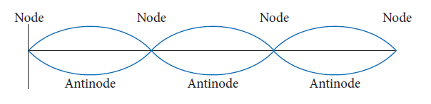 (Nodes + 3 humps = 2 marks)

b What is the frequency of the third harmonic?

Answer: 3f1= 3 × 216 = 648 Hz (1 mark)

c What is the wavelength of the third harmonic?

Answer:  (1 mark)

d What is the speed of the waves in the string?

Answer: v = f λ = 648 s–1 × 0.30 m = 194.4 m s–1 (1 mark)

e If the upper limit of human hearing is 20 kHz, which is the highest harmonic that can be heard?

Answer: For the nth harmonic, fn= n× f1= 216n.

216n s–1 < 20 000 s–1

N < 92.5, so up to the 92nd harmonic is audible. (1 mark)

(6 marks)

7 A certain substance has a refractive index of 1.24.

a What is the critical angle for light travelling through this substance to the interface with the air?

Answer: c ≈ 53.75° (1 mark)

b If the speed of light in a vacuum is 3.00 × 108 m s–1, what is the speed of light in this substance?

Answer:  ≈ 2.42 × 108 m s–1

(1 mark)

(2 marks)

8 A convex lens has a focal length of 10 cm. An object 2 cm high sits 15 cm to the left of the lens. Describe the image in terms of:

a whether it is real or vertical and its orientation

b its position

c its size and the magnification.

Answer:

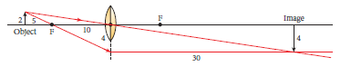

Either show diagram or working for the following answers. (1 mark)

a Image is real and inverted. (1 mark)

b Position is 30 cm to the right of the lens. (1 mark)

c Image is 4 cm tall, M = 2 (1 mark)

(4 marks)